### 

Software Process Life Cycle

Văn Lang Admissions

# Revision Table

|  |  |  |  |
| --- | --- | --- | --- |
| Author | Date | Reason for changes | Version |
| Tai Nguyen | 22/10/2016 | Incremental Process | 1.0 |
| Tai Nguyen | 3/11/2016 | Update Process | 1.1 |
| Tai Nguyen | 12/1/2016 | Update Process | 1.2 |
| Minh Doan | 24/04/2017 | Fix Template | 2.0 |
|  |  |  |  |
|  |  |  |  |

Table of Contents

Revision Table 1

1. INTRODUCTION 3

1.1. Purpose 3

1.2. Audience 3

2. PROCESS 4

2.1. Process Flow 4

2.2. Activities 5

3. ROLES AND RESPONSIBILITY 6

4. PROCESS DECISION 7

# INTRODUCTION

## Purpose

It should offer a sampling of the key aspects of the problem and provide a solution that is simple enough to understand and implement easily.

The analysis of an iteration is based upon user feedback, and the program analysis facilities available.

It supports analysis of the structure, modularity, usability, reliability, efficiency, & achievement of goals.

## Audience

The intended audiences of this document are:

|  |  |
| --- | --- |
| Intended Audience | Description |
| All team member | All member have a meeting and discuss about process |
| The mentor | People give an advice and support group during implement process. |
| Stakeholder on customer side | People give requirement of project |

# PROCESS

## Process Flow

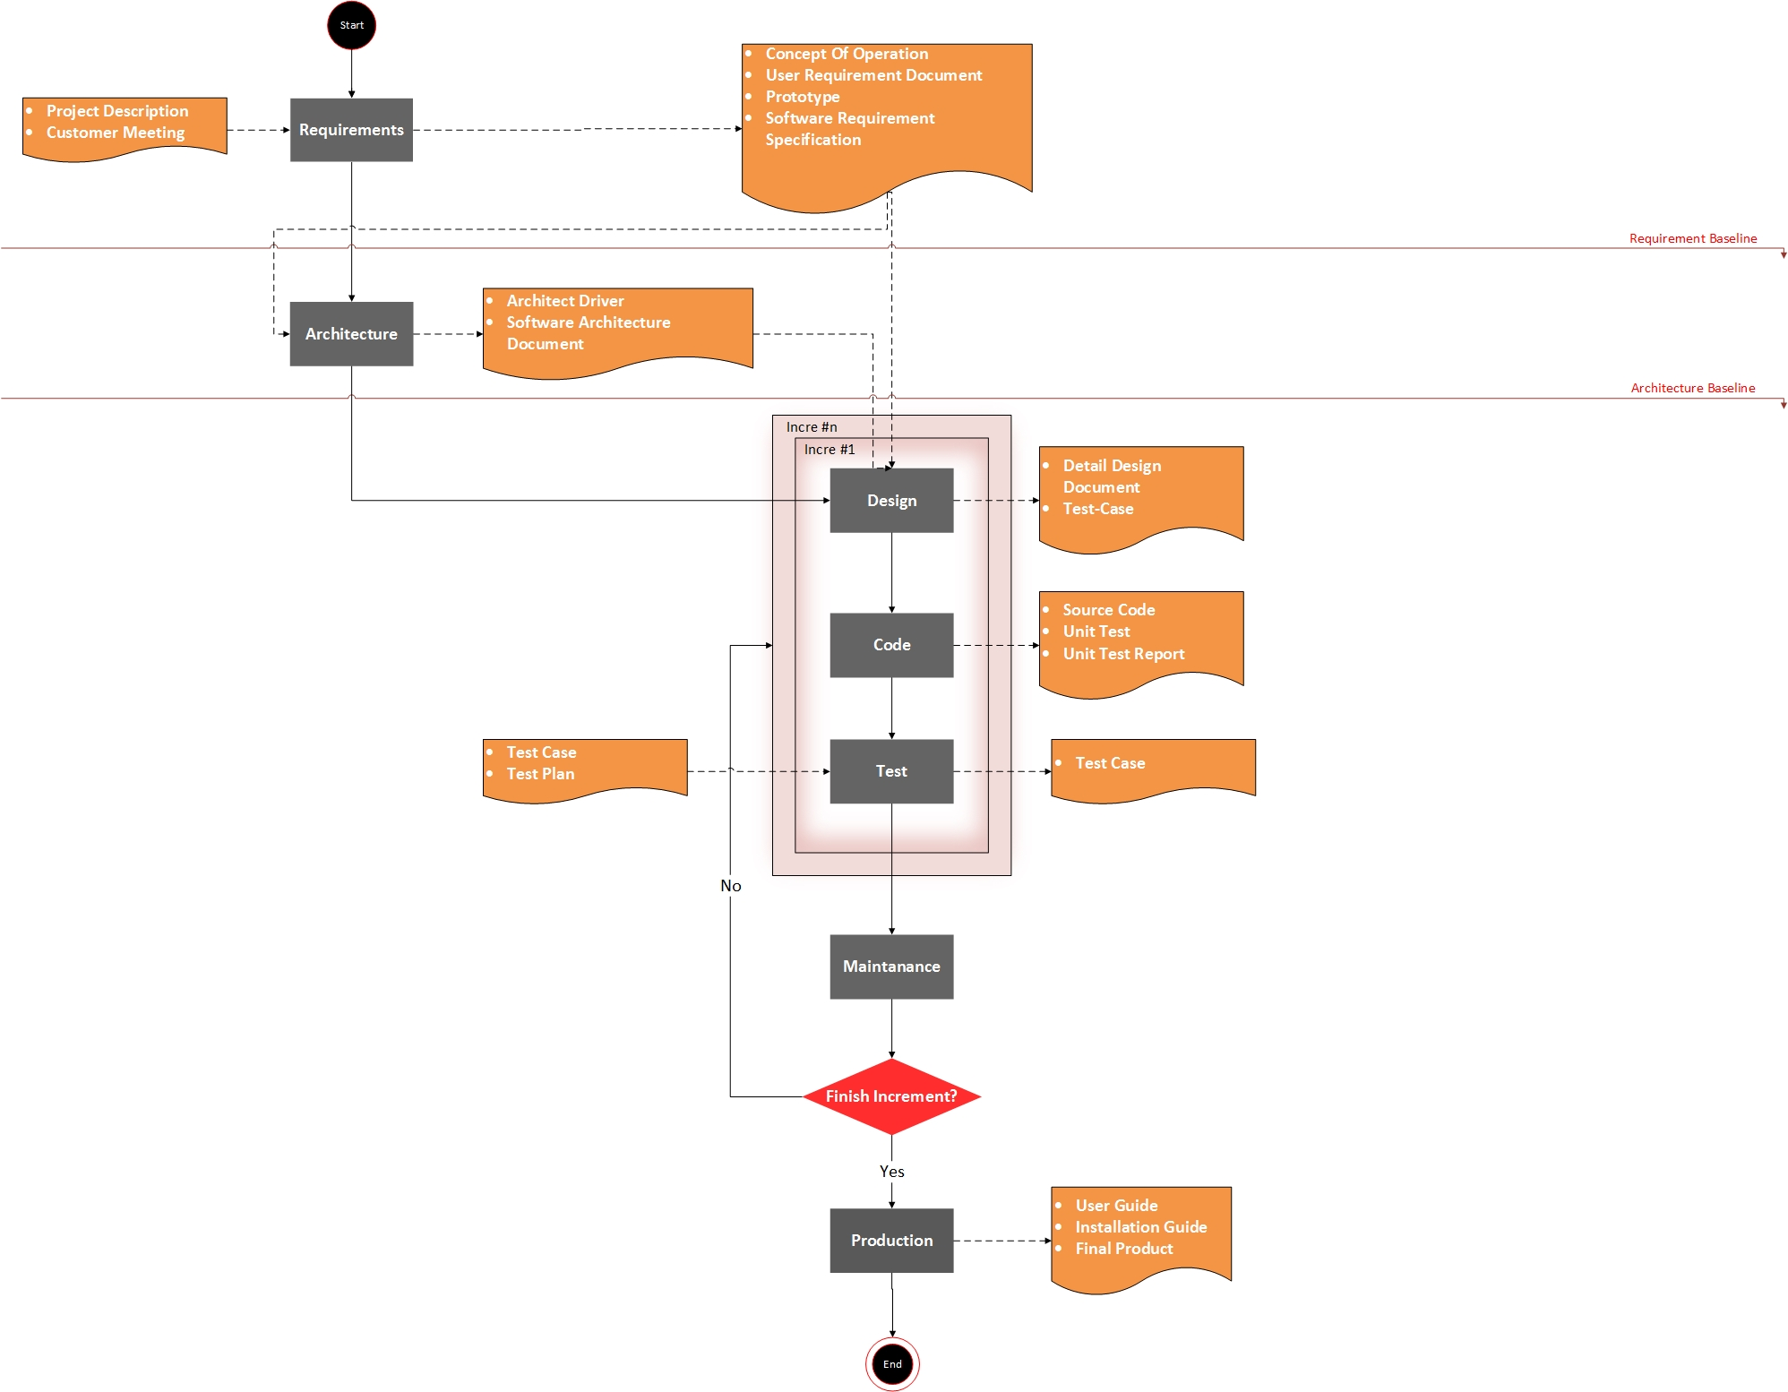

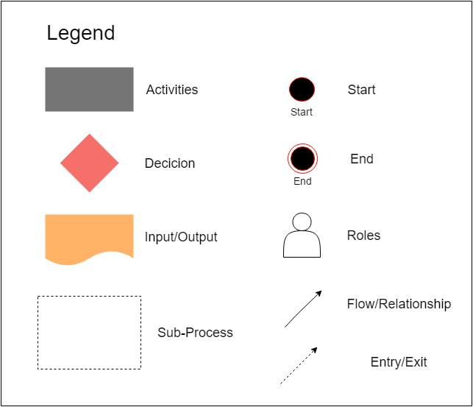

## Activities

|  |  |
| --- | --- |
| Action | Description |
| Requirement | * The Customers provide information about business process of them. * All requirements are fully collected through meetings with customers then analyze and asked, confirm with the customer. * These requests will be evaluated to choose important requirements, so we can arrange priority of requirement. |
| Architect | The requirements of customers are divided and grouped into sections (modules) each function to manage the conduct of software development easily.  Hardware and software are agreed after discussions with customer in meetings.  Analyze quality attribute and trade-off with the customer to bring best thing for customer and team project. |
| Design | Training Design member  Make use case description, use-case diagram, sequence diagram, database.  Determine all functions, quality attribute |
| Implement | Training Implement member  Programming all interface and function for the program. |
| Test | Training Test member  write document: System test, Acceptance test, Summary report, Test case, Bugs List  Run test case |
| Maintain | Guide customer how to use and install program |

# ROLES AND RESPONSIBILITY

|  |  |
| --- | --- |
| Role | Responsibilities |
| Requirement Leader | Manage about strategy, schedule, resources, and environment to identify, analyze, document and manage requirement of Capstone Project. |
| Architecture Leader | Discuss the ideas, objectives, requirements and budget of a project and in some cases help to select a site. |
| Design Leader | * Manage and review about design document. * Redefine a design brief within the constraints of cost and time; * Presenting finalized ideas and concepts to clients or account managers. |

# PROCESS DECISION

Reference: [BSS_SoftwareProcessDecision_v1.0](CapstonProject/4.SUBMIT_PLACE/4.4%20TAI_NGUYEN/PLANNING/BSS_SoftwareProcessDecision_v1.0%20.docx)